ECE 465 Lab 2
Boolean Minimization and Prime Implicants
- Introduction
When creating circuits, there are some Boolean algebra expressions that will create large circuits, that at the end of the day, are redundant. Take the expression:
$$ABC+A^{'}+A'BC$$
The way this is expressed is pictured below in the circuit. Note that we are not using more than 2-input and/or gates:
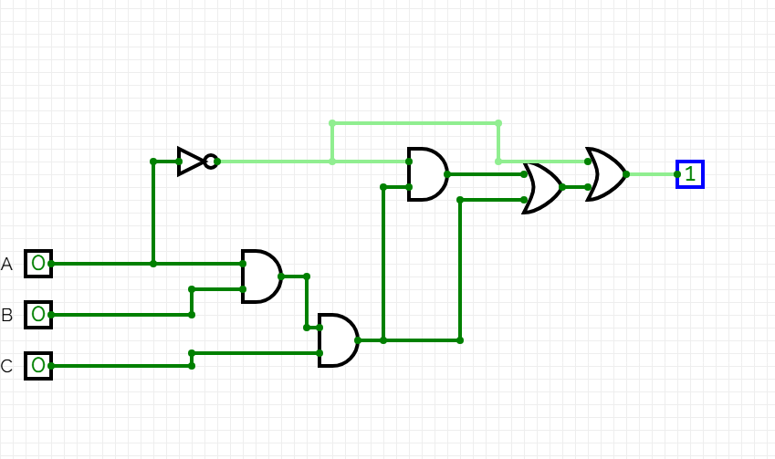
This circuit costs 3-And gates and 2-or gates. Using basic algebra minimization, we can get the same logic circuit for less.
$ABC+A^{'}+A'BC$ – We can apply the absorption theorem
$ABC+A'$ - Once again, another application of absorption theorem
$BC+A'$ - This is our final answer. Now take a look at the minimized circuit

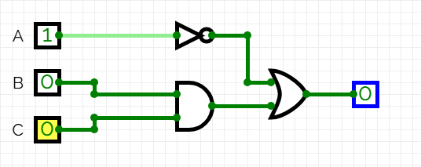

In using boolean minimization, we are able to only use one and gate and one or gate. A reduction of 3 logic gates.

- Practice using Boolean Algebra.
Now you will create multiple circuits using the subsequent equations. On the surface, boolean minimization usually results in a more efficient circuit, but that isn’t always the case. Simplify the following equations.

2a. $A^{'}B^{'}C^{'}+A^{'}B^{'}C+A'C'$
2b. $AB^{'}\left(C+BD\right)+A'B'C$

- Understanding of prime implicants
When it comes to algebraic minimization, there are a lot of rules and theorems to memorize. To get around this, we use Kavanaugh Maps, K-Maps for short. We use these to find Implicants. An implicant can be defined as a product/minterm term in Sum of Products or sum/maxterm term in Product of Sums of a Boolean function.
$ABC+A^{'}+A'BC$ first we must find the minterms where $∑f\{0,1,2,3,7\}$

3a. Draw the K-Map of the equation, and find the simplified equation

3b. Simplify the following equation with a K-map. Is it the same as using boolean algrebra? $ABC+A'B+B'C$

